A-Trane club

PHRONESIS, Live To Everything, 7.12.2014, 21:00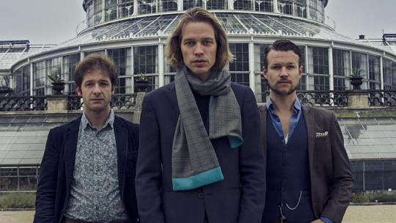
Jasper Hoiby double bass, Ivo Neame piano, Anton Eger drums

This British/Scandinavian jazz trio has the ability to inspire, excite and move people that very few jazz bands can do. Their charismatic live performances have captured the hearts and minds of worldwide audience where Jazzwise Magazine described them as “the most exciting and imaginative piano trio since EST”. Phronesis began touring in 2013 in Australia, Germany, Scandinavia, Switzerland and the UK. They also performed in North America during the summer and in October they repeated their amazing ‘Pitch Black’ project for three shows in Belgium. The trio recorded their fifth album live in the round over three sold out EFG London Jazz Festival performances in November. In April this year, they released ‘Life To Everything’.

Artist website: www.phronesismusic.com

REGGIE MOORE TRIO, 9.12.2014, 21:00
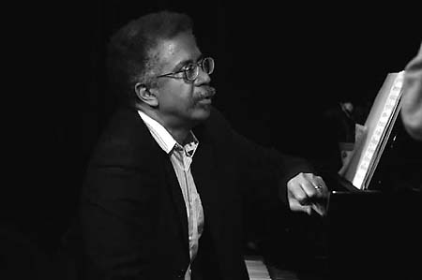

Reggie Moore piano, Martin Lillich bass, Michael Kersting drums

Through his incredible 50 years career, Reggie Moore shared the stage with many great legends such as Gary Bartz, Benny Golson, Johnny Hartman, Woody Shaw or Berry Carter. Reggie Moore, New York City born artist is able to touch his audience in an indescribable way. Jazz critic Nat Hentoff described Reggie as having a “strongly propulsive beat, crispness of articulation, and emotional directness”. Together with Martin Lillich and Michael Kersting, Reggie has repeatedly re-plumbed the art of the piano trio in recent years. These three musicians create lyrical and sensual atmosphere in which they can communicate with their audience.

Artist website: He doesn't have official website!

B Flat jazz club

Diego Pinera Berlin Quartet, 16.12.2014, 21:00
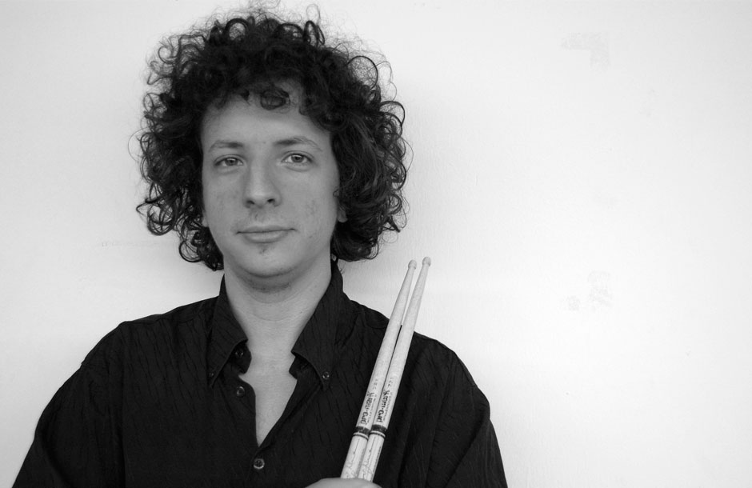
Peter Ewald saxophon, Tino Derado piano, Andy Lang bass, Diego Pinera drums

Montevideo (Uruguay) born musician Diego Pinera has been Berlin resident since 2003 when he first moved here. With his quartet he brings in his compositions a new approach to Latin jazz where sometimes he brings his music closer to Pop and Modern Jazz rather than sticking to traditional Latin Jazz styles. He is very well known for his original, rich rhythm and improvisational approach. However his style of playing is deeply rooted in the traditional music of Latin America.Pinera studied drums at the Berklee College of Music (USA), University of Music in Havana (Cuba) and also University of Music and Theater in Leipzig (Germany). As a sideman he played with great names such as Miguel Zenon, Dan Tepfer, Nils Wogram or Wilson de Oliveira.

Artist website: www.diegopinera.com

Damir Bacikin Band, Damir OutLoud, 20.12.2014, 22:00
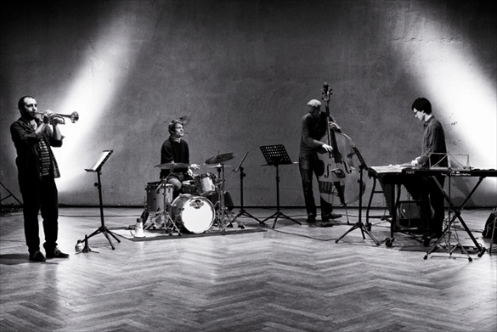
Damir Bacikin trumpet, Hannes Daerr tenor sax and bass clarinet, Ferdinand Hendrich trombone, Julius Heise vibraphone, Noriaki Hosoya bass, Tom Dayan drums

Bacikin’s classical roots are following the adventurous jazz paths traced by Gil Evans and Maria Schneider. Damir’s band combines elements of experimental noise, jazz, drum ‘n’ bass and new improvised music which developed its own authentic sound. They create wide spectrum of dynamic forms and a musical dialogue with woodwinds and brass on one side and vibraphone, double bass and drums on the other. They were awarded a studio Grant by the city of Berlin in 2012, the ensemble released their first album “Graduation day”.

Artist website:www.damiroutloud.wix.com

Eberhard-Kowatsch-Gühlcke-Lübke play ERIC DOLPHY, 15.12.2014, 21:00

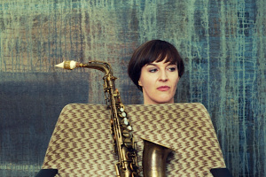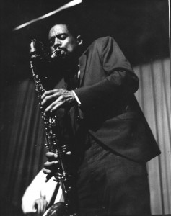

Eric Dolphy was among that select group who take What Is and create What If. They change the way we experience the world. Although his is not a household name, Dolphy helped to redefine jazz in the early 1960s and today stands as one its most revered and influential avant-garde figures. Master of alto saxophone, flute and bass clarinet, a soloist and composer of seemingly boundless ideas. From propulsive, darting improvisations to sublime and deeply sensitive ballads, his sound remains fresh and compelling fifty years after his death.

One of the performing musicians is Silke Eberhard, alto saxophonist and clarinetist. Silke studied at the Musikhochschule Hanns Eisler in Berlin, followed by David Liebman´s masterclass in the USA. Her work was described as”mastery of both instruments is impressive, but so is her take on music: it is fun, it is light-footed, rhythmically and structurally complex, emotional and technically superb”. She has performed and/or recorded with musicians such as Ulrich Gumpert, David Liebman, Johannes Bauer, Sabine Worthmann, Günter Baby Sommer, Dave Burrell or Gerry Hemingway.

Artist website: www.silkeeberhard.com

Kunstfabrik Schlot jazz club

Uwe Kropinski Trio, 20.12.2014, 21:30
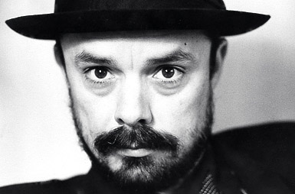

“Kropinski is not a guitarist, the man is a guitar”. That is how this guitar legend was described by one music critic. Kropinski was born in Berlin where he also studied jazz and classic guitar at the Hochschule fur Musik. During the years 1973 and 1976 he became influenced by Conny Bauer which has reflected on his work. During the late 80’s he travelled USA and played with David Friesen. He uses very special guitars with 39 frets made by the guitar maker from the Netherlands, Theo Scharpach.

Artist website: www.kropinski.com

Triometrie, Zimtstern 21.12.2014, 21:00
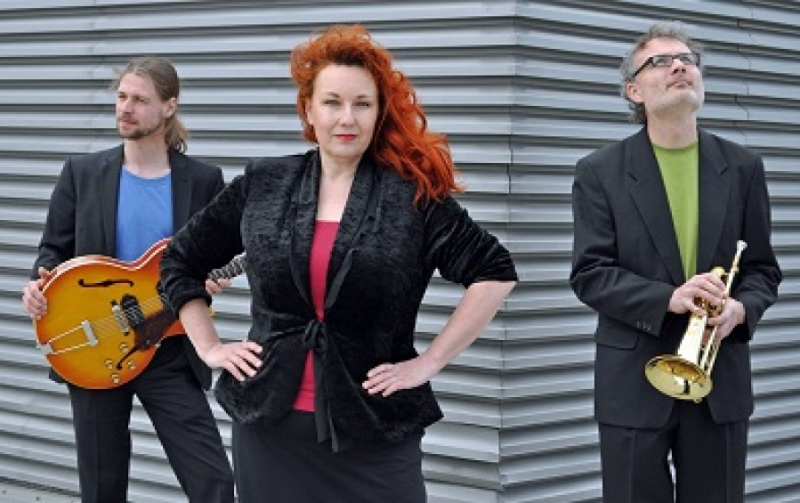
Anja Sonntag vocal, Stefan Gocht fih, tb and Benjamin Doppscher guitar

Three Berliners Anja Sonntag, Stefan Gocht and Benjamin Doppscher are experimenting between classical music and jazz, together with mixing various styles of musical traditions and different backgrounds. Triometrie creates distinct styles which never just stand beside each other, they find the perfect balance of arrangement, interpretation and improvisation. In their Christmas program “Zimtstern” you can look forward Silent Night, Gloria in Excelsis Deo or A Child is born.

Artist website: I didn't find their official website!

JazzKeller 69

Johnny La Marama, 5.12.2014, 21:00
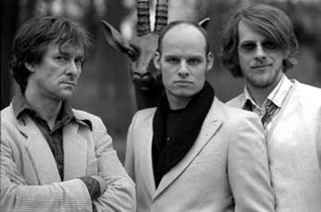

Kalle Kalima guitar, Chris Dahlgren bass, Eric Schaefer drums

Johnny La Marama is an extraordinary jazz guitar trio from Berlin. Every audience is pleased by avantgarde and rock influences melting into an African ethnic sound. The trio uses free improvisation but at the same time the rhythm remains steady. A loose ostinato is often the backbone of their creative music.

Artist website: www.kallekalima.com

Georg Gräwe, Still and Stories, 14.12.2014, 16:00
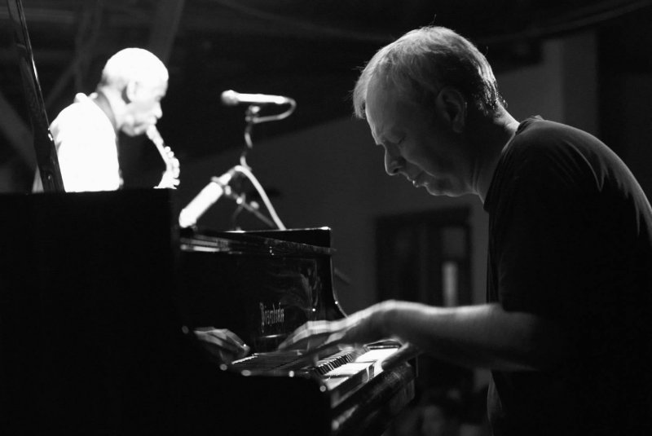

German born pianist and composer Georg Gräwe has been composing and performing since the age of 15. Since then he has been leading a variety of ensembles, ranging from trio to chamber orchestra formats, which have involved some of the leading instrumentalists in the contemporary music. His compositions include chamber music, scores for films, theatre productions or radio drama. Since 2000 he has also written three operas.

Artist website:He doesn't have official website!

Quasimodo Berlin

Mike Russell’s Funky Soul Kitchen, 27.12.2014, 22:00

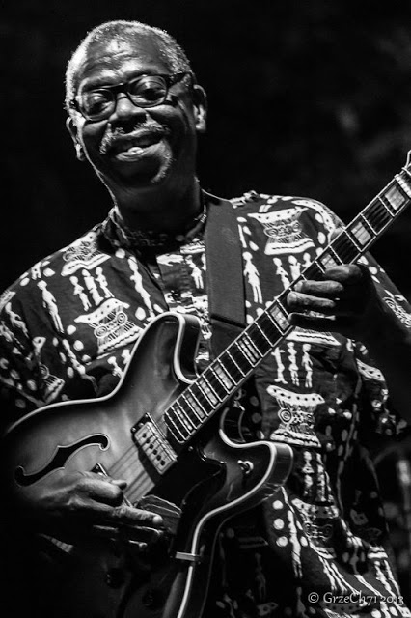

Mike Russell guitar, Rudy Reidl key, Jens Korodi bass, Di Carlo drums

Russell’s professional career started in the 60’s with soul and blues band. Composing and songwriting was his early interest which lately resulted in studio work with Columbia Records. His first record with title “Black Woman” was released in 1970 where he was also nominated by Grammy. Since Russell moved to Berlin in 1989 he has performed with many great artists such as Billy Bang, Eddy Harris and many others.

Artist website: www.blackheritage.de

Yorckschlosschen

Henry Heggen’s Boggie Bash, 19.12.2014, 21:00
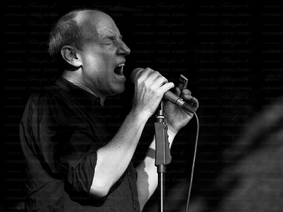

Harmonica, great blues voice and boyish charm, is it how Henry can be described in short. Eventhough he was born in Florida he moved to Europe very young where he met Chris Turner from whom he learned the sharp playing. In 1976 he came up with the legendary Jug Band “Have Mercy” to Germany where he soon founded his own band. He also performed as a support artist for Joe Cocker. From a Hamburg music scene he is the one that cannot be ignored.

Artist website: www.henryheggen.de

Harald Hertels Jass Tigers, 20.12.2014, 21:00
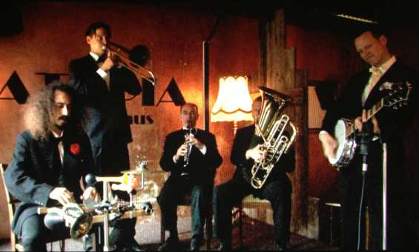

At the beginning of this year Harald Hertel gathered four other musicians and started a hot jazz band with music which originated nearly 100 years ago. The name of the band “Jass” is not a spelling mistake but this name before 1920 used to be often mentioned. The musical impression shapes usually the clarinet or saxophone and also sultry vocals which brings back the present.

Artist website: www.basinstreet.de

